Test Automation Development Guidelines

Creating a new branch 2

Commit changes 3

Pushing changes 4

Run test in Azure Pipeline 5

Create a Pull Request 6

Link work items 7

Set auto complete 8

*Important: An automation Task (Azure work item) should have one to one relationship to a specific branch.

A task is not considered complete until a pull request has been completed for it

# Creating a new branch

1. Make sure current branch is Master with no changes
2. Make sure name is according to the user story or functionality to be automated

# Commit changes

ideally one should commit for every scenario completed, one could also commit once the whole User Story or functionality is automated

note: is ideal to divide changes into various commits to then push everything altogether

1. Commit with a brief description of the changes

# Pushing changes

Once the whole user story or functionality is completed and working locally

1. Push the previously committed changes to the previously created branch

# Run test in Azure Pipeline

To make sure the implemented solution is working in the Azure Pipeline, our official test runner, we’re going to run the pipeline for the previously created branch.

1. Navigate to [ApolloQA Pipeline](https://dev.azure.com/biberk/Apollo/_build?definitionId=69) in Azure Devops
2. Run the pipeline for the previously created branch

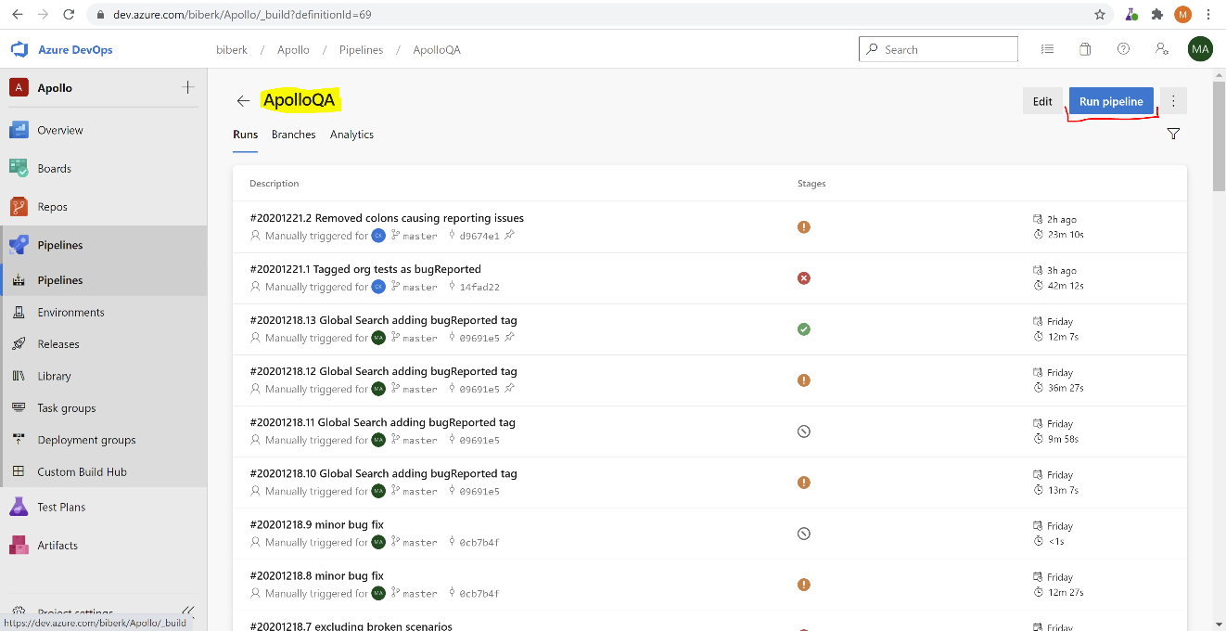

# Create a Pull Request

Once the pipeline test is successful, a pull request should be created to be reviewed before merging into master

1. Navigate to [Pull Requests](https://dev.azure.com/biberk/Apollo/_git/ApolloQA/pullrequests) in Azure Devops
2. Click on the “New Pull Request” Button
3. Select the previously created branch
4. Click on the “Create” Button

# Link work items

Every pull request must have two linked work items associated.

1. Related Task
2. Test Case must be created/updated according to the work done.
3. Test Case must be added to:  
   Regression Testing->Automated.

# Set auto complete

Once work for the related task is fully completed and tested in the pipeline with no failures. The PR can be set to auto complete.

This will trigger completion after all requirements have been met.

